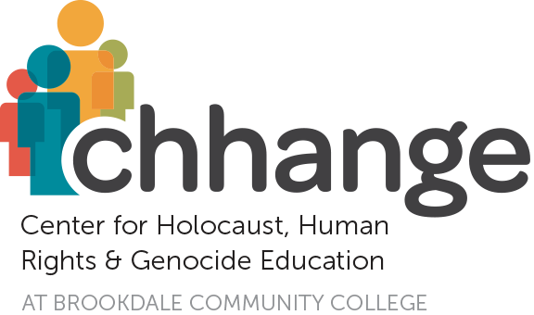
The 36th Annual Colloquium: May 9, 2018

Stand Up Against Hate

Featuring Susan Bro and Chief Investigator David D’Amico

SPONSORSHIP OPPORTUNITIES

Official Sponsor: $10,000

8 Tickets to VIP Reception and Annual Colloquium; Digital Signage on Large Screen and Verbal Recognition at Annual Colloquium; Signage at 35+ Individual Workshops.

Keynote Speaker Sponsors: $ 7,500

6 Tickets to VIP Reception and Annual Colloquium; Digital Signage on Large Screen and Verbal Recognition at Annual Colloquium.

VIP Reception Sponsors: $ 5,000

4 Tickets to VIP Reception and Annual Colloquium; Digital Signage on Large Screen and Verbal Recognition at Annual Colloquium.

School Sponsors: $ 2,500
Provides Bus Transportation to Colloquium for School Children
4 Tickets to VIP Reception and Annual Colloquium; Digital Signage Group Listing on Large Screen at Annual Colloquium.

Individual Workshop Sponsors: $ 1,000

2 Tickets to VIP Reception and Annual Colloquium; Digital Signage Group Listing on Large Screen at Annual Colloquium.

- - - - - - - - - - - - - - - - - - - - - - - - - - - - - - - - - - - - - - - - - - - - - - - - - - - - - - - - - - - - - - - - - - - - - - - - - - - -

Annual Colloquium Sponsorship Reply Form: rsvp by 4/19/18

☑ YES, count us in! Enclosed is my/our gift of $ ___________
for SPONSORSHIP of Chhange’s 2018 Annual Colloquium to be held on May 9, 2018.

Name: _______________________________ Contact: _________________________
Address: _______________________________________________________________
Phone: _______________________________ email: _________________________

Payment Options:
Checks payable to Chhange
Credit Card: Visa MC AMEX Discover

Card Number _________________________ Expiration Date __________ CID# _____
Signature _____________________________ Date _________________________

Kindly return form & payment to: Chhange, Brookdale CC, 765 Newman Springs Rd, Lincroft, NJ 07738
Donations are tax-deductible as allowed by the IRS.

